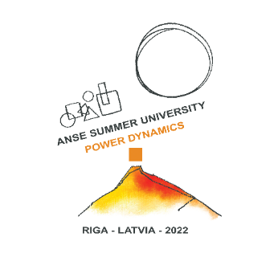
Call for SU2022 workshops is open for
ANSE Summer University 2022, August 22-26
Riga, Latvia

We are pleased to invite you to share your professional experience through leading a workshop, which should be strongly connected to the central theme of this Summer University:
“Power Dynamics and Human Empowerment in an environment of elevated uncertainty”.
The theme remains the same as for previously planned, but due to Covid travel restrictions moved from 2021 to 2022, Riga Summer University.

During our venue we will strive to understand the role of supervision and coaching during these times of elevated uncertainty, when power dynamics change- politically, institutionally, socially, inter and intra personally. We will try to find our own “shadows” and “blind spots” of the Power dynamics in supervision and coaching, and learn how to remain human –centred for the empowerment of others.

When submitting your workshop proposals, please consider that we will follow this criteria for our workshop selection:
- connection to the main theme “Power Dynamics and Human Empowerment in an environment of elevated uncertainty”
- your personal professional experience in practical application of the concept you wish to propose
- proposed approaches/methods from different applicants contributing to overall diversity of approaches/methods explored during this SU 2022
- applicants coming from geographically diverse areas
- language of the workshops: English
- length of the workshop: 1,5 hours

The deadline for applications is 15st of February 2022.
Please send your application or questions to: riga.anseuni2021@gmail.com
! Note to those of you who already sent your applications before Summer Uni 2021 moved to 2022: if you still wish to lead the workshop that you proposed, we kindly ask you to just forward your initial email with the attached workshop proposal to: riga.anseuni2021@gmail.com, confirming that you still would like to travel to Riga and lead the workshop.
After submitting your workshop application, we kindly ask you to allow us two weeks for the selection of workshops. You will hear back from us by 1st of March.

Workshop leaders are exempt from the registration fee for the Summer University!
As for the benefit for ANSE community, we would very much like to ask workshop leaders to publish an article, or summary about the workshop in ANSE Journal 6-2, deadline September 30, 2022. It is not compulsory, but very much encouraged.

Guidelines for your application
Please include following information about your workshop:

Title of the workshop
Maximum number of participants
Learning outcome
(max 250 words)
Workshop concept-description: approaches, methods, etc.
(max 250 words)

Your professional biography (max 250 words)

Your practical experiences in application of your workshop concepts within contexts of Power Dynamics and Human Empowerment in an environment of elevated uncertainty (max 250 words)
Should it be needed, could you also lead this workshop in an online environment, such as Zoom, MS Teams, Skype?

Please note: according to regulation (EU) 2016/679 of 27 April 2016, your data will be only used for summer university contents.

